1. Compare Google, Bing, and DuckDuckGo
- Open:
  - Google
  - Bing
  - DuckDuckGo
- Search for:
best budget smartphones 2024
- Take a screenshot of the first page from each search engine.
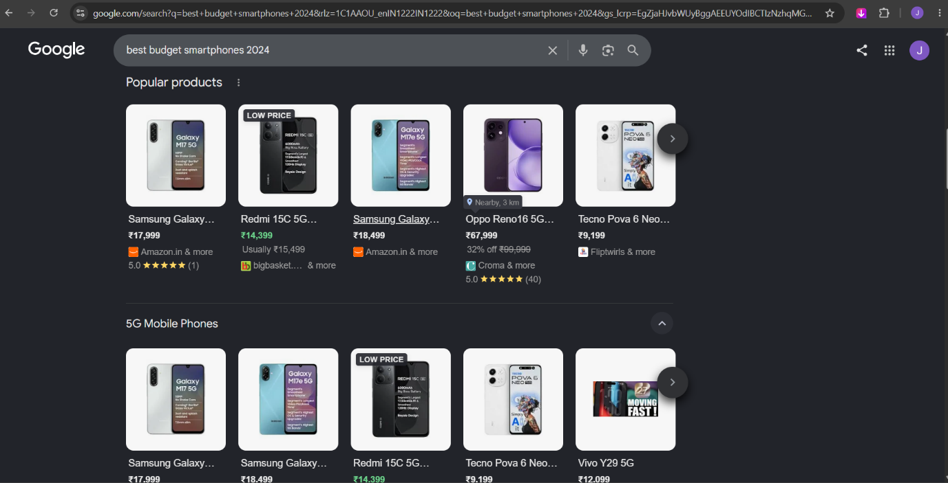
- Fill in a table like this:
Search Engine | Top Result | 2nd Result | 3rd Result | Observations
Google
Bing
DuckDuckGo
Things to compare:
- Are shopping results shown?
- Are there AI summaries?
- Which websites appear first?
- Are ads displayed at the top?

2. Table of Popular Search Engines
You can copy this into Google Docs or Excel.
Search Engine | Unique Feature
Google | Largest search index and highly relevant results
Bing | Microsoft Rewards and integration with Windows/Copilot
DuckDuckGo | Strong privacy protection; does not track users
Yahoo | Combines search with news, email, and finance services
Brave Search | Independent search index with privacy-focused search

3. Organic vs Paid Results
Organic search results are webpages that appear naturally because Google's algorithm considers them relevant to the search query. Paid results are advertisements that businesses pay to display at the top or bottom of the search page and are usually marked with labels such as "Ad" or "Sponsored." For example, if I searched for a smartphone, an Amazon advertisement marked "Sponsored" would be a paid result, while a review from a technology website like TechRadar or GSMArena would be an organic result.
Replace the example with websites you actually see during your search.

4. Google Search Process Flowchart
START
│
▼
Crawling
│
▼
Indexing
│
▼
Ranking
│
▼
Search Results
Descriptions
Crawling
- Google's bots visit websites and discover new or updated pages.
- They follow links to find more content.
Indexing
- Google stores and organizes the information it finds.
- Pages are analyzed so they can be searched later.
Ranking
- When someone searches, Google ranks indexed pages.
- The most relevant and useful pages appear first.

5. Trending Topic Search
Choose any current trending topic (for example, a new movie release or gadget launch).
Search it on Google and fill in this table.
Type | Website | Why?
Organic Result 1 |  | Not marked as "Ad" or "Sponsored."
Organic Result 2 |  | Appears naturally in search results.
Paid Result 1 |  | Labeled "Ad" or "Sponsored."
Paid Result 2 |  | Labeled "Ad" or "Sponsored."

